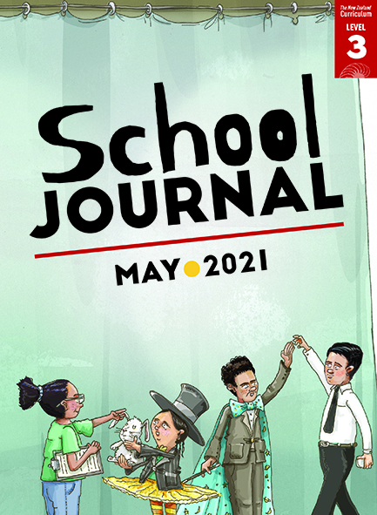
School Journal
Level 3, May 2021
Year 5

Stranded
by Fraser Smith

The Learning Progression Frameworks (LPFs) describe significant signposts in reading and writing as students develop and apply their literacy knowledge and skills with increasing expertise from school entry to the end of year 10.

Overview
Piki and his koro are trying to save some stranded whales, an experience that reminds Piki of his dad and his own troubles.
A PDF of the text is available at www.schooljournal.tki.org.nz

Themes
- Environmentalism | - Animal welfare | - Compassion | - Whānau

Related texts
“Māui” SJ L3 May 2016 | “Ancestors” SJ L3 Aug 2018 | “Whānau” SJ L3 May 2019

Strengthening reading behaviours (what to notice)
Text structure and features | Requiring students to:
- Implied information  “Your dad has a bit to learn, eh,” said Koro with a smile.  “… Whales stick together.”  “Like us, eh, Koro?”  … when Dad went away. He would be out next week … – no longer stranded like the whales.  so she could keep her eye on them  - Technical information  She placed her hands on Toho’s flanks and began to gently rock him. “To restore his balance,” she explained.  “Now you try, but stay clear of the tail. He might get agitated and slap it. You don’t want a whack.”  “The bones in their pectoral fins are like the ones in your hand.” | - integrate their prior experience and vocabulary knowledge with the context to infer where Dad is and that he will be coming home soon  - identify the key ideas and information, focusing on the verbs and adverbs to follow the instructions and visualise the actions being described.

Vocabulary
Some te reo Māori | tāmure, Te Oneroa-a-Tōhē, Ahipara, upokohue, Āe, tohorā, whanaunga, Whitiwhitia e te rā, Mahea ake ngā pōraruraru, Makere ana ngā here, Haere, whānau, Kāo
Topic-related terms | double meaning of “stranded”, pipi beds, lugging, possies, chilly bin, Project Jonah, blister, shallows, disoriented, flanks, refloat, pod, agitated, matriarch, pectoral fins, dubiously, volunteers, pontoon, spouted

Helpful prior knowledge (pre-reading and introducing the text)
- Whales sometimes become stranded and people try to refloat them.
- Whales have special importance to tangata whenua.
- Whales need to be taken care of while they are waiting to refloat.
- Families support each other during difficult times.

Possible reading and writing purposes
- Find out how a young boy and his koro help to save some important sea creatures
- Explain some ways to take care of stranded whales
- Identify and describe the author’s purpose.
See Effective Literacy Practice in Years 5–8 for information about teaching comprehension strategies (Teaching comprehension)
and for suggestions on using this text with your students (Approaches to teaching reading).

Possible curriculum contexts
This text has links to level 3 of The New Zealand Curriculum in: ENGLISH HEALTH AND PHYSICAL EDUCATION

Understanding progress
The following aspects of progress are taken from the Learning Progression Frameworks and relate to the specific learning tasks below. See the LPFs for more about how students develop expertise and make progress in these aspects:
- Reading for literary experience
- Making sense of text: reading critically; using knowledge of text structure and features; reading to organise ideas and information
for learning
- Using writing to think and organise for learning.

Strengthening understanding through reading and writing
Select from the following suggestions and adapt them according to your students’ strengths, needs, and experiences.
Note: Most of these activities lend themselves to students working in pairs or small groups.
- Before reading, discuss what the students know about whales stranding around New Zealand. Have you seen pictures of this or watched it on the news? Have you seen it first-hand? You could provide photographs or show a video of a whale stranding to activate the students’ prior knowledge. You could encourage English language learners to discuss these in their own language.
- After the first reading, discuss what the story is about. Have the students work in pairs to describe, using their own words, what happened in the story.
- Encourage the students to make connections between their prior knowledge and the text. You could prompt them with some sentence starters, such as “When I read the part about … it made me think about/remember …” and “The part about …
reminded me of when …” Draw out their understanding by asking What did you learn about whales/Dad/family? Where is Dad? Why would Nan keep them close? How did the author show whales were like people? Ask them to find parts of the text to support their answers.
- Ask the students questions to clarify why the author might have written this story. Does the story contain facts or opinions? How do we know? How can we find out? How do the illustrations help tell the story? What were you thinking when reading the story? What connections did you make? What do you think the author wanted us to think about after reading the story?
- Give the students stickies and ask them to use them to identify any unfamiliar words and phrases. Revise strategies for finding the meaning of unknown words such as using word knowledge, looking for words within a word, identifying prefixes and suffixes, making connections with their prior knowledge, rereading to look for clues, reading on to see if the meaning becomes clear, and using a dictionary. Discuss how readers need to be flexible depending on the information available. Talk through some examples from the text where the meaning is not directly evident, for example, “sack was full of tāmure” – the students need to read on to “four big fish” to understand what tāmure are. Discuss how it’s not always necessary to define a word precisely. For example, across the text there are many references to the “matriarch”. Tell the students to build what meaning they can from the context and then make a suggestion. They could select their own words to focus on, or you could provide words from the topic-related terms or words that you noticed were challenging. They could use a table like the one below:
Word | I think this means | Why I think this | Dictionary meaning
- The author talks about Piki and his father’s living arrangements. Have the students scan back through the text looking for evidence about this. They could use the Jigsaw template at the end of this TSM, writing what the text says on the left-hand side and what they think the author means on the other side.
- Have the students explain how to care for stranded whales. Firstly, they could make a list of the things that Piki and Koro did to help the whales. Then they could look for additional information on the Project Jonah website. The students could present this information to the group orally, visually, or digitally.

“Stranded” Jigsaw

What I think the author is trying to say:
Like the whales, they live close by each other in pods.
They look out for each other.
They have a matriarch – a leader.

What the story says:
Page 9: They were all going to live together for a bit. Piki and his dad and Nan and Koro, just until Dad found his feet.

Find more examples and write them into the two jigsaw pieces below. (Write the text in the left-hand piece and what you think the author is telling us in the right-hand piece.)

